Smers methods - FOR AIM1

MAIN FOLDER: C:\Users\nveit\OneDrive - Northwestern University\Research\GITHUB\PhD\Aim1

10/14:

1. **A_Smers_processing_dataPrep.m**

preprocessing the TEPs into its trials , each of them per intensity and also filtered

Individual subject mat files saved in:

Y:\Spinal Stim_Stroke R01\AIM 1\Subject Data\SS01\TEPs

1. Gets rid of bad pulses
2. Filters signals with various methods below

Output:

**subjStruct**

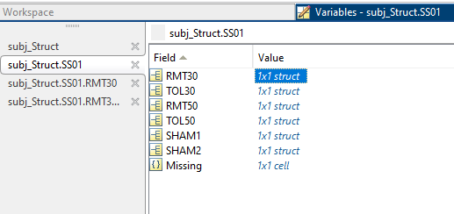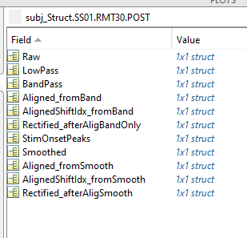

Aligned function:

* Used last signal as REFERENCE signal
* Performs a cross correlation with “currentSignal”
* Finds the idxs of the maximum correlations, and computes the lag between the signals.
* From those 3 options: find the maximum with a shift less than 20 points (10 ms)
* The currentSignal is being shifted in reference to the last signal
  + Negative lag: means that reference is ahead, so the currentSignal is shifted forward (delayed - +2)

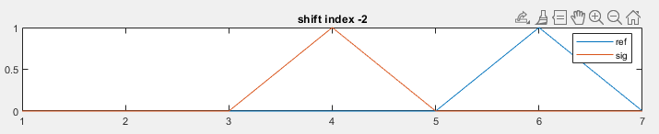

* Positive lag: means reference signal came first, so currentSignal needs to be shifted back (-2)

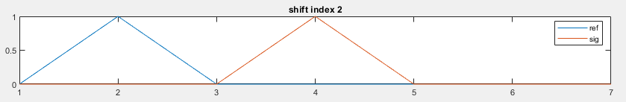

Sweeping reference signal - and seeing where if the most correlated:

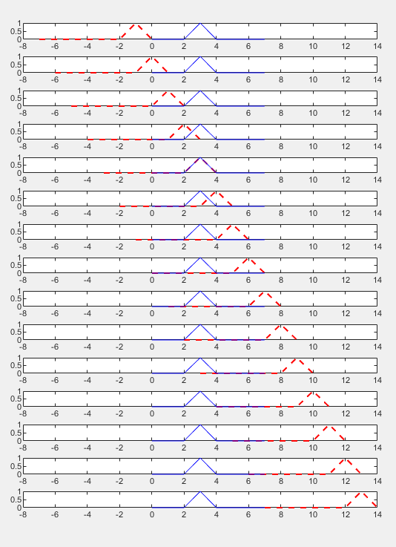

In this case, it was when the ref signal (red) was shifted backwards 3 (shiftIndex -3), so add 3 current Signal,

Saving:

(pulsenum, 1) shiftAmount: % This represent the amount that signal was shifted by

            % For example: 2, means signal was shifted by 2 forward

            % -4, signal was shifted -4 points back

(pulsenum, 2) maxIndex_alignedSigns: this represents the index of the maximum correlation of the two signals  - gotten by element wise multiplying and getting the max index.

From here can see if the correlation was based between the stim artifact or the waveform MEP

Methods:

* Smoothed: Bandpassed 20-500, smoothed (Window ~ 3ms),
* Aligned_fromSmooth: Bandpassed 20-500, smoothed (Window ~ 3ms), aligned
* Rectified_afterAligSmooth: rectified Aligned_fromSmooth

1. **B_Smers_P2P_AUC.m**

Where clicking each set of muscle/intervention/TP to get the stim onset, latency, peaks, and end. Based on those estimated clickings, it gets one signal by one signal to find its own parameters:

“signal” : is one of the methods shown above from code A.

Inputs:

“plotMethod” variable delineates which one we are using - *mainly using* Aligned_fromSmooth

“rectifiedMethod” : variable to be used to get the AUC Rectified_afterAligSmooth

Output:

**ALL_SUBJ_STRUCT.mat**

 SUBJ+"_B_TEPs_PulsesFeatsStruct.mat"

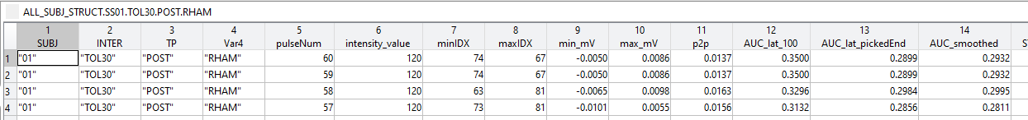

For one muscle at a time

1. *Manually click: stim artifact, latency, peak1, peak2, and END*
   1. All pulses signals are plotted overlaid red-yellow-blue (least)
2. Then from last signal, feeds into getPeaks and gets relative parameters to the ones manually selected. When havent found anything for 20 trials, it assumes no MEPs and fills in NaNs for resting trials.

[minIDX, maxIDX, min_mV, max_mV, p2p, latency, End, flagged, STIM_ARTIFACT_PEAK] = peaksAuto(signal, foundLat, minIDX_picked, maxIDX_picked, sitmIDX_picked);

* Looks for stim onset and peaks within 25 points, or 12.5 ms of clicked
* Finding latency:
  + Get derivative of signal, get std of 1:10 indices, and set the threshold of 3x that
  + Then portion the signal between -25 and 25 of stim onset of derivative and find the first index that exceeds the threshold above
* End: defined as latency+100 (50 ms later)
* Need to find a P2P > 0.03 mV
* Flagged: found a P2P - but no latency - so the latency was assigned to the “picked/clicked” latency

 Getting features of each MEP:

* Latency from “stim index” (latency_fromOnset_idx): What was the latency from the stim artifact to “Latency”

All below use the following signal:

rect_sig = subj_Struct.("SS"+SUBJ).(INTER).(TP).(rectifiedMethod).(muscle_channel)(pulseNum,:);

  rectifiedMethod = Rectified_afterAligSmooth

* AUC_lat_100: gets AUC of signal with fixed end (100 ms after calculated latency)
* AUC_lat_pickedEnd: gets AUC of signal with end manually clicked. (may not be fixed since latency may change)
* AUC_smoothed: further smooths the rectified signal of choice with low pass filter (20 Hz)
* p2p

1. C_Smers_RecruitmentCurves.m

C:\Users\nveit\OneDrive - Northwestern University\Research\GITHUB\PhD\Aim1

Input:

**ALL_SUBJ_STRUCT.mat**

 SUBJ+"_B_TEPs_PulsesFeatsStruct.mat" (from code B)

Output:

Max_structs.mat

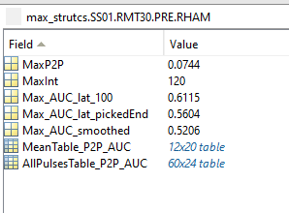

AllPulsesTable_P2P_AUC:

*SAVED AS EXCEL - All 5 trials per subj, inter, TP, muscle (same as* **ALL_SUBJ_STRUCT.mat** but concatenated

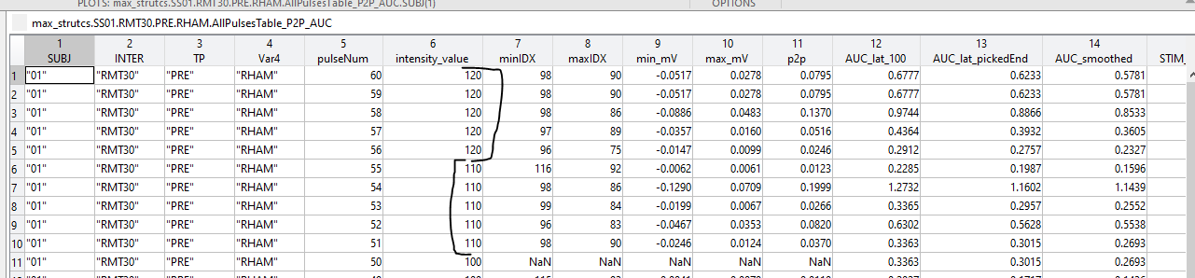

In MeanTable_P2P_AUC:

* Get mean p2p, AUCs ( 3 methods), latencies (2 methods)
  + SHOULD DO CORRELATIONS TO SEE HOW THIS ARE CORRELATED AND DECIDE IF SHOULD MOVE ON WITH ALL OR JUST ONE
* A lot of calculations and normalizations based on the MEAN of 5 trials